> max(average_acc_history$validation_acc)

[1] 0.8129177

> eval <- evaluate(model, test_data, test_targets, verbose = 1)

423/423 [==============================] - 1s 2ms/step - loss: 1.6026 - categorical_accuracy: 0.3521

> eval

loss categorical_accuracy

1.6025562 0.3520668

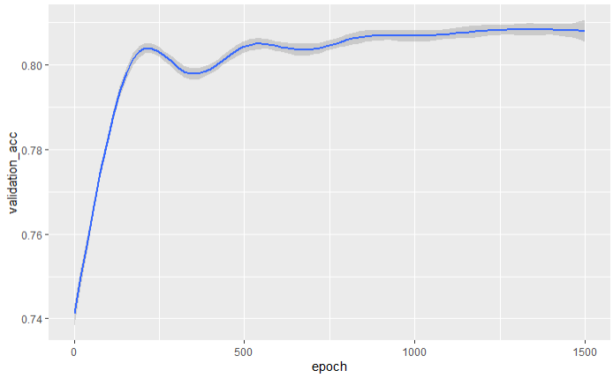

Model:

#train_data <- matrix_data

train_data <- data.matrix(matrix_data)

test_data <- data.matrix(matrix_data_test)

train_targets <- data.matrix(matrix_targets)

test_targets <- data.matrix(matrix_targets_test)

# Function to build the model

build_model <- function() {

model <- keras_model_sequential() %>%

#layer_batch_normalization(axis = -1L, input_shape = dim(train_data)[[2]]) %>%

layer_dense(units = 64, activation = "relu", input_shape = dim(train_data)[[2]]) %>%

layer_dropout(0.3) %>%

layer_dense(units = 64, activation = "relu") %>%

layer_dropout(0.3) %>%

layer_dense(units = 8, activation = "softmax")

model %>% compile(

optimizer = optimizer_sgd(learning_rate = 0.2),

loss = "categorical_crossentropy",

metrics = "categorical_accuracy"

)

}